
You are a world famous safe cracker! When old safes are found or when people lose
their combinations, they come to you for help. Use the clues to help crack the safes.

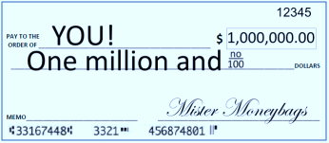
1. The first number is the mean of the data.
The second number is the median of the data.
The third number is the mode of the data.
Texts Received Last Week
5 | 6 | 7 | 8 | 14 | 15 | 15
The combination is ______, ______, ______.
Now open it up and see a million dollar check inside!


2. The first number is the mean of the data.
The second number is the median of the data.
The third number is the mode of the data.

Blu-Ray Prices
$20 | $15 | $22 | $17
$19 | $17 | $16 | $26
The combination is ______, ______, ______.
Now open it up and see your tickets to Paris inside!


3. The first number is the outlier of the data.
The second number is the mean of the data with
the outlier included.
The third number is the mean of the data without
the outlier.
Texts Received Last Week
3 | 16 | 6 | 5 | 4 | 2
The combination is ______, ______, ______.
Now open it up and see the royal jewels inside!


4. The first number is the mean of the data.
The second number is the mode of the data.
The third number is the outlier of the data.
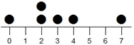

The combination is ______, ______, ______.
Now open it up and see the title to a private island inside!

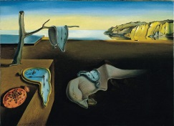
5. The first number is the greater value: the mean
or the outlier of this data:
2, 13, 16, 18, 20, 21
The second number is the greater value: the median
or the mode of this data:
16, 16, 17, 17, 18, 18, 18
The third number is the greater value: the mode
or the outlier of this data:
The combination is ______, ______, ______.
Now open it up and see the artwork inside!

46, 47, 47, 47, 48, 48, 51, 52, 53, 78

John Parke, 2014

KEY

You are a world famous safe cracker! When old safes are found or when people lose
their combinations, they come to you for help. Use the clues to help crack the safes.


1. The first number is the mean of the data.
The second number is the median of the data.
The third number is the mode of the data.
Texts Received Last Week
5 | 6 | 7 | 8 | 14 | 15 | 15
The combination is 10, 8, 15.
Now open it up and see a million dollar check inside!


2. The first number is the mean of the data.
The second number is the median of the data.
The third number is the mode of the data.

Blu-Ray Prices
$20 | $15 | $22 | $17
$19 | $17 | $16 | $26
The combination is 19, 18, 17.
Now open it up and see your tickets to Paris inside!


3. The first number is the outlier of the data.
The second number is the mean of the data with
the outlier included.
The third number is the mean of the data without
the outlier.
Texts Received Last Week
3 | 16 | 6 | 5 | 4 | 2
The combination is 16, 6, 4.
Now open it up and see the royal jewels inside!


4. The first number is the mean of the data.
The second number is the mode of the data.
The third number is the outlier of the data.


The combination is 3, 2, 7.
Now open it up and see the title to a private island inside!


5. The first number is the greater value: the mean
or the outlier of this data:
2, 13, 16, 18, 20, 21
The second number is the greater value: the median
or the mode of this data:
16, 16, 17, 17, 18, 18, 18
The third number is the greater value: the mode
or the outlier of this data:
The combination is 15, 18, 78.
Now open it up and see the artwork inside!

46, 47, 47, 47, 48, 48, 51, 52, 53, 78

